NSW Health | Bushfire response social
 | November 2023
v1 | www.health.nsw.gov.au

Social
Tile example (please use png file provided in channel) | Social copy
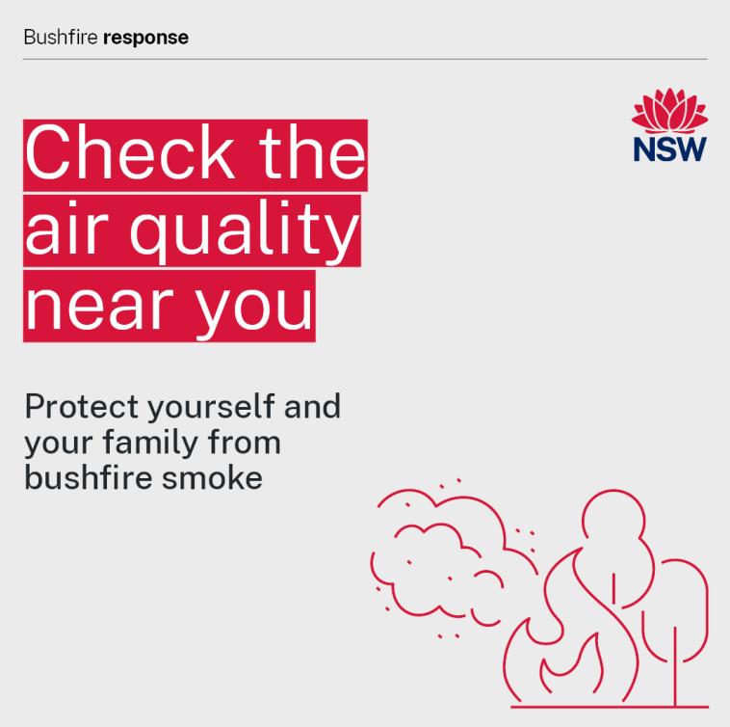 | [This tile and the associated copy is for use in regional, remote or rural areas, or areas where bushfire is likely]  Smoke from [insert ‘bushfires’ or ‘hazard reduction burning’ based on the reason for smoke in your area] can affect your health.  Some people are more sensitive to the health effects of smoke, including older people, those with underlying health conditions and children.  To protect yourself and your family:  - Check the air quality levels near you and follow the recommended health advice.  - Reduce the time you spend outdoors.  - Keep your asthma puffer handy – if you use one.  Check the air quality in your area:  https://www.airquality.nsw.gov.au/  Find out how to protect yourself and your family from bushfire smoke: https://www.health.nsw.gov.au/bushfires  If it is smoky and you live in an area where a bushfire is possible, check and follow emergency warnings from the NSW Rural Fire Service: https://www.rfs.nsw.gov.au/fire-information/fires-near-me
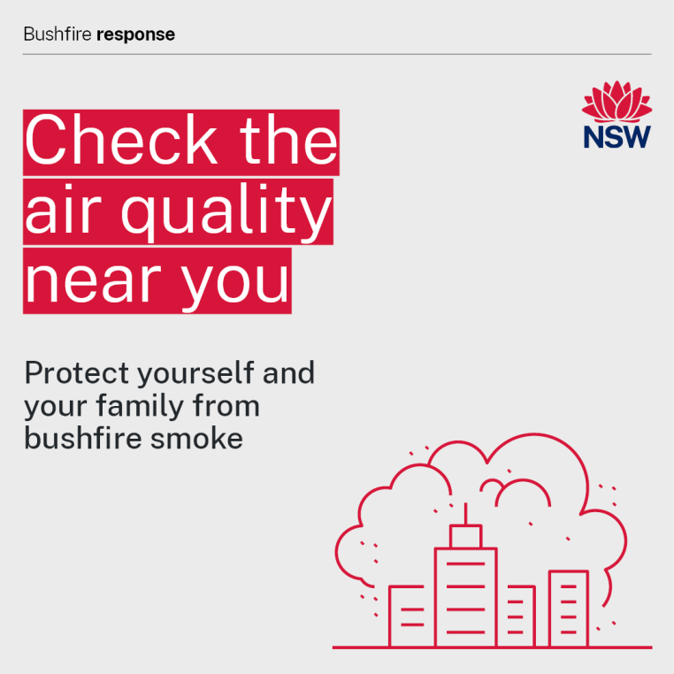 | [This tile is for use in urban and metropolitan areas]  Smoke from [insert either ‘bushfires’ or ‘hazard reduction burning’ based on the reason for smoke in your area] can affect your health.  Some people are more sensitive to the health effects of smoke, including older people, those with underlying health conditions and children.  To protect yourself and your family:  - Check the air quality levels near you and follow the recommended health advice.  - Reduce the time you spend outdoors.  - Keep your asthma puffer handy – if you use one.  Check the air quality in your area:  https://www.airquality.nsw.gov.au/  Find out how to protect yourself and your family from bushfire smoke: https://www.health.nsw.gov.au/bushfires
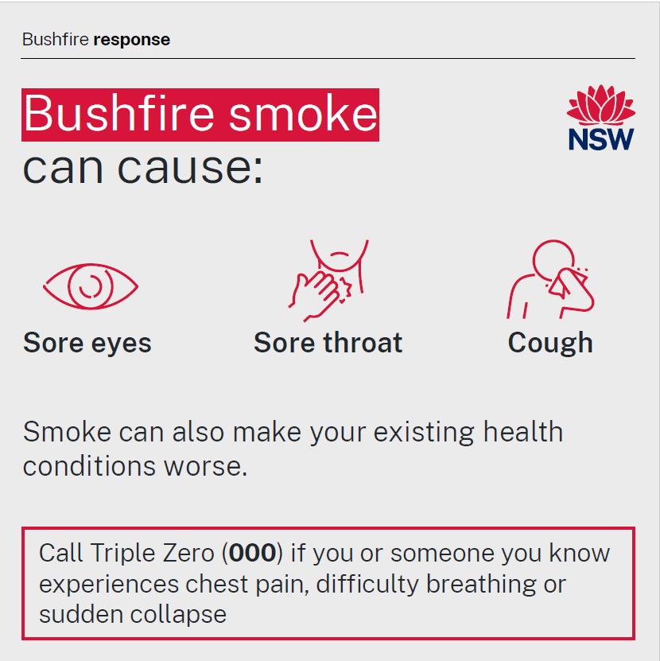 | Common symptoms of smoke irritation include:  - itchy or burning eyes  - sore throat  - cough.  For most people these symptoms are temporary and will clear after the smoke disappears.  Some people are more sensitive to the health effects of smoke, including older people, those with underlying health conditions and children.  If you are more sensitive to bushfire smoke, follow your doctor’s advice about how to stay safe. Keep your medication, medical devices and action plan for your health condition, for example an Asthma Action Plan, close by.  Contact your doctor or the 24-hour healthdirect helpline on 1800 022 222 if you are concerned about any symptoms.  Call Triple Zero (000) in a medical emergency such as difficulty breathing, chest pain or sudden collapse.  Check the air quality in your area:  https://www.airquality.nsw.gov.au/  Learn if you may be more sensitive to bushfire smoke:  https://www.health.nsw.gov.au/environment/bushfire/Pages/know-high-risk.aspx  Find out how to protect yourself and your family from bushfire smoke: https://www.health.nsw.gov.au/bushfires
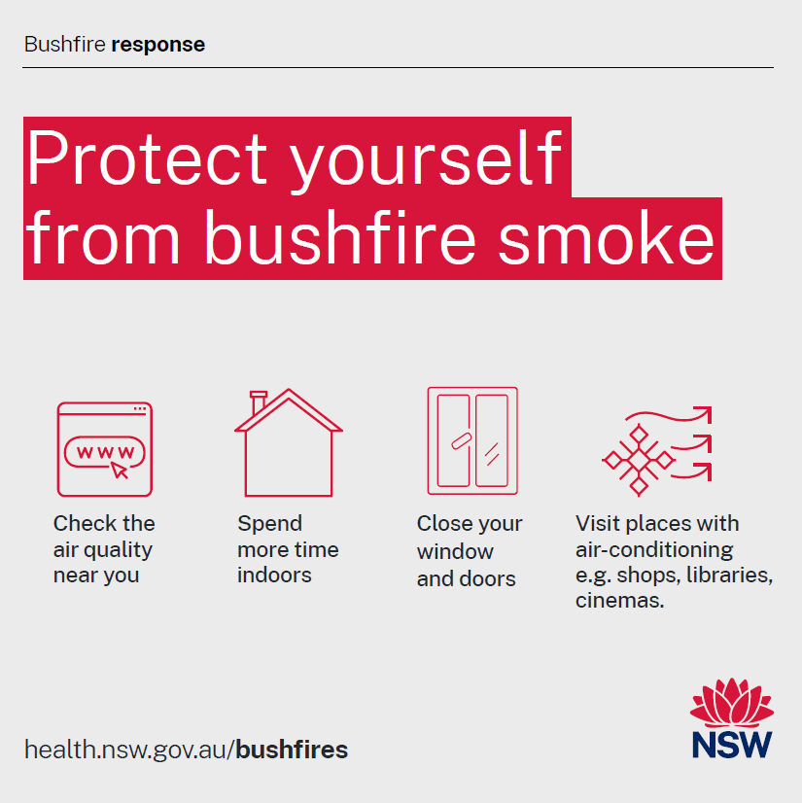 | Take steps to protect yourself and your family from bushfire smoke:  - Check the air quality in your area and follow the recommended health advice https://www.airquality.nsw.gov.au/  - Reduce the time you spend outdoors.  - Keep the air inside your home as clean as possible by closing windows and doors. Avoiding indoor sources of air pollution and use an air purifier with a high efficiency particle air (HEPA) filter if you have one.  - Spend time in air-conditioned venues like cinemas, libraries and shopping centres.  - Consider using a P2/N95 face mask if you cannot avoid the bushfire smoke. Your mask must fit properly to work well. If you have a heart or lung condition to talk to your doctor before using a mask.  For more information on the steps you can take: https://www.health.nsw.gov.au/environment/bushfire/Pages/bushfire-protection.aspx
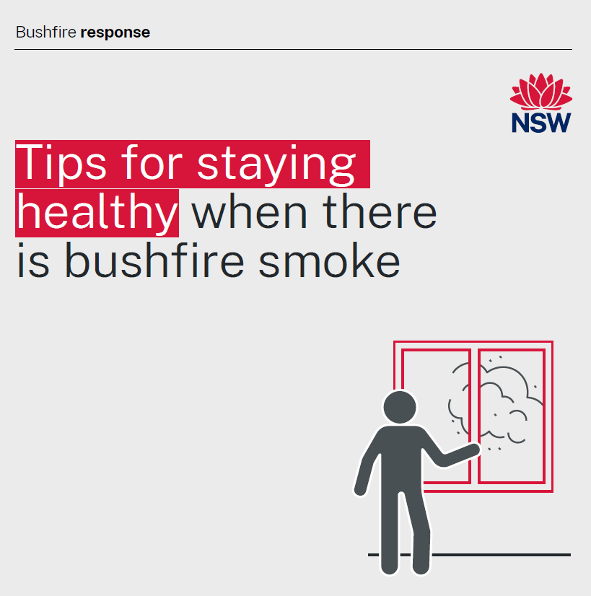 | To protect yourself and your family from bushfire smoke:  - Check the air quality in your area and follow the recommended health advice: https://www.airquality.nsw.gov.au/  - Reduce the time you spend outdoors on poor air quality days.  - Keep the air inside your home as clean as possible by closing windows and doors. Avoiding indoor sources of air pollution and use an air purifier with a HEPA filter if you have one.  - Spend time in air-conditioned venues like cinemas, libraries and shopping centres.  - Consider using a P2/N95 face mask if you cannot avoid the bushfire smoke. Your mask must fit properly to work well. If you have a heart or lung condition to talk to your doctor before using a mask.  For more information: https://www.health.nsw.gov.au/environment/bushfire/Pages/bushfire-protection.aspx  If it is smoky and you live in an area where a bushfire is possible, check and follow any emergency warnings associated with threats from bushfires. Visit NSW Rural Fire Service: https://www.rfs.nsw.gov.au/fire-information/fires-near-me
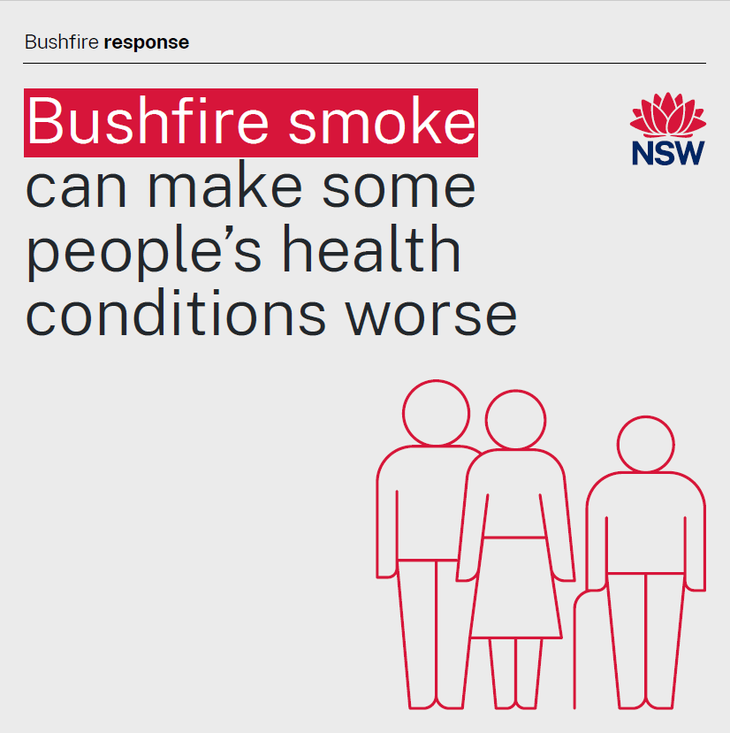 | You may be more sensitive to the health effects of bushfire smoke if you:  - have a pre-existing heart or lung condition like asthma, emphysema and angina  - are pregnant  - are aged over 65  - are an infant or a young child  - have diabetes.  If you are more sensitive to smoke, follow your doctor’s advice about how to stay safe.  Keep your medication, medical devices and action plan for your health condition, for example an Asthma Action Plan, close by.  Contact your doctor or the 24-hour healthdirect helpline on 1800 022 222 if you are concerned about any symptoms.  Call Triple Zero (000) in a medical emergency if you or someone in your care has difficulty breathing, chest pain or sudden collapse.  Find out how to protect yourself and your family from bushfire smoke: https://www.health.nsw.gov.au/bushfires
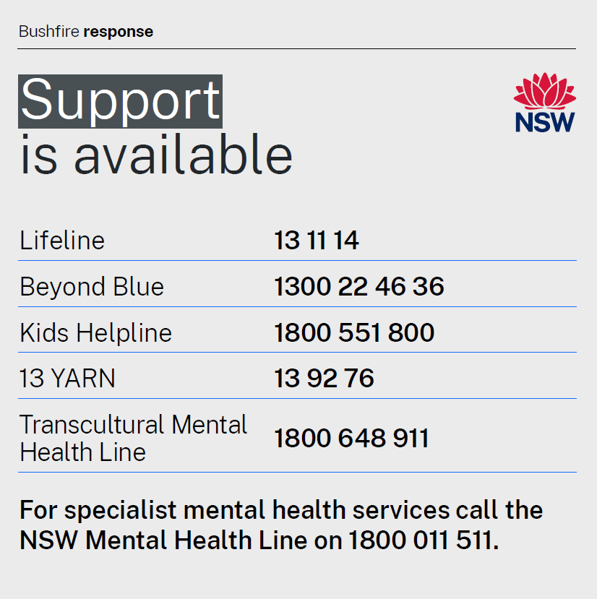 | It is completely normal to experience a range of emotions if you are affected by bushfires.  Take care of yourself and your mental health and seek support if you or the people around you need it.  A range of mental health services and professional help is available and only a phone call away.  If you or someone you know needs to talk to someone, call:  - Lifeline on 13 11 14  - Beyond Blue on 1300 22 46 36  - Kids Helpline on 1800 551 800  - 13 YARN, run by Aboriginal people, on 13 92 76.  - Transcultural Mental Health Line on 1800 648 911.  If you or someone you know is in immediate danger, please call Triple Zero (000) or go to your nearest hospital emergency department.  For specialist mental health services call the NSW Mental Health Line on 1800 011 511.  For more information on managing your mental health: https://www.health.nsw.gov.au/mentalhealth/resources/Pages/bushfire-mental-health-support.aspx

NSW Health
NSW Ministry of Health  1 Reserve Road  St Leonards NSW 2065 | Office hours:  Monday to Friday  9.00am — 5.00pm  W: www.health.nsw.gov.au

