NSW Health | Bushfire recovery social copy
 | December 2023
MASTER | www.health.nsw.gov.au

Social
Tile example (please use png file provided in channel) | Social copy
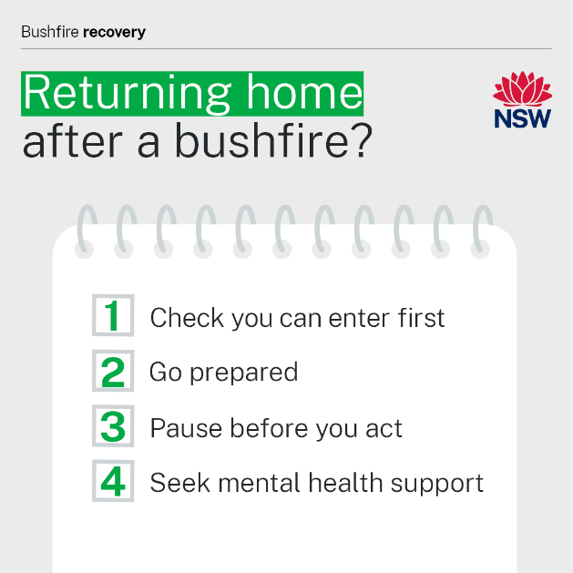 | Stay safe when returning home after a bushfire.  Steps you can take to look after your health:  - Ask your local emergency services if it is safe to return to your property. Do not enter until you have been told it is safe.  - Take protective clothing to wear, food, water, sunscreen and a hat.  - Everyday items like food, drinking water, medicines, wastewater systems or swimming pools may no longer be safe after a bushfire. Read advice at the link below before you go.  - Seek support if you or someone you know is affected by bushfires. For 24-hour mental health support contact Lifeline on 13 11 14, Beyond Blue on 1300 22 4636 or 13YARN, run by Aboriginal people, on 13 92 76.  For more health advice on returning home safely: https://www.health.nsw.gov.au/environment/bushfire/Pages/bushfire-recovery.aspx
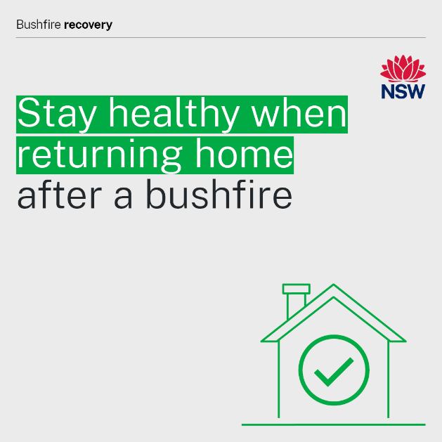 | Everyday items in and around your home may not be safe to use after a bushfire.  They may be affected by heat, fire, ash, debris or fire retardants.  To stay safe:  - wait for local emergency services to say it is safe for you to return.  - be aware and stay away from unsafe debris and damaged structures – including ash, asbestos, chemicals and wastewater systems.  - discard any food that has been affected by heat or fire or has been unrefrigerated.  - do not drink or use any water that may be contaminated.  - take medicines that have been affected by heat or fire to your local pharmacy for disposal.  Learn more: https://www.health.nsw.gov.au/environment/bushfire/Pages/bushfire-recovery.aspx
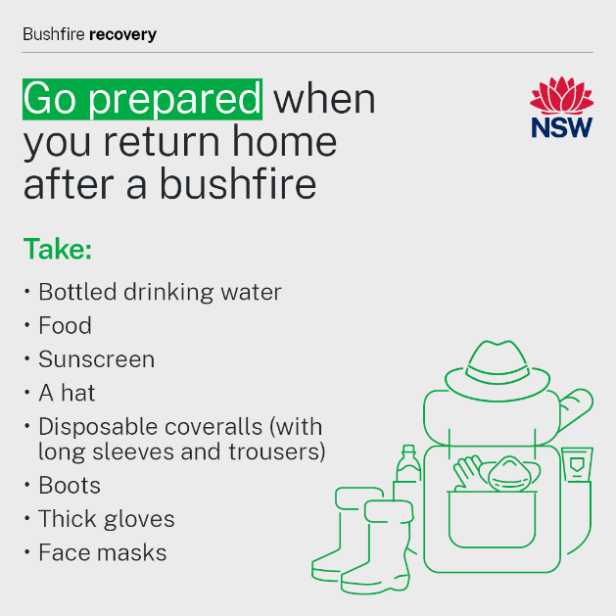 | Pack a bag of supplies and protective clothing before you return home after a bushfire.  Importantly, it’s best to limit time spent at your property and avoid taking children, if you can, because there can be many hazards.  ​ Take:  - bottled drinking water  - food (perishable food should be kept cool in an esky or cooler bag)  - sunscreen  - a hat.  Wear:  - protective clothing including sturdy footwear and heavy-duty work gloves  - disposable coveralls (with long sleeves and trousers)  - P2/N95 face masks.  You can buy these you’re your local hardware or workplace supply stores.  When it’s time to leave the property:  - pack all protective clothing items into a garbage bag  - wash your hands after removing your protective clothing  - clean your shoes before wearing them again.​​  For more information on returning home safely:  https://www.health.nsw.gov.au/environment/bushfire/Pages/bushfire-recovery.aspx
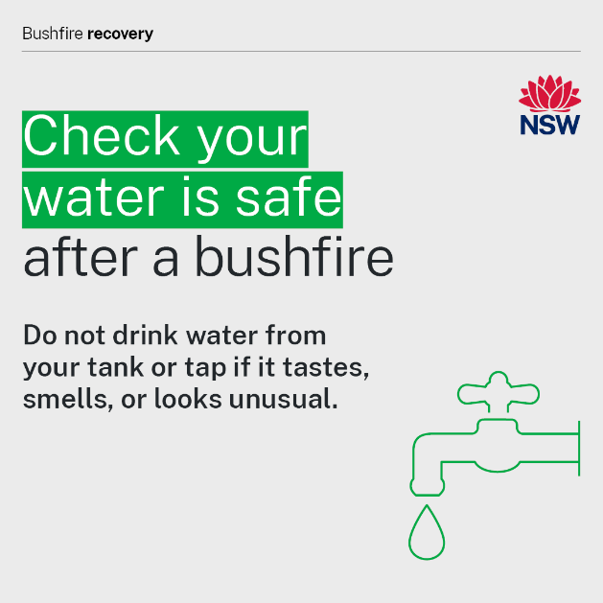  OR  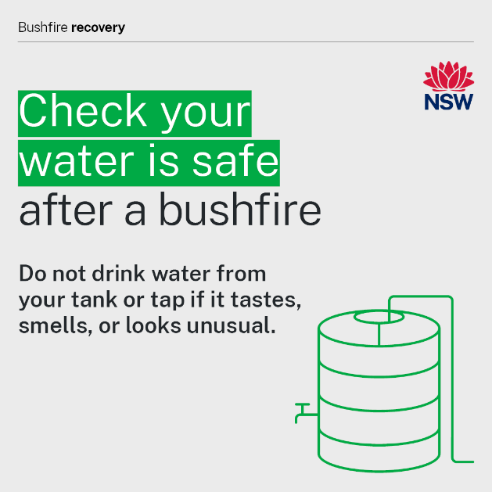 | After a bushfire your rainwater tank or drinking water can be contaminated by ash, debris, dead animals or fire retardants.  Do not drink the water or give it to animals if it tastes, smells or looks unusual.  If you think your water has been contaminated:  - use a different safe water supply, such as bottled water, for drinking, preparing food or ice, and cleaning teeth until your tank can be cleaned and refilled.  - if no other drinking water is available, water can be disinfected by boiling.  More information on rainwater tanks and water after a bushfire: https://www.health.nsw.gov.au/environment/water/Pages/rainwater-bushfires.aspx  Check for boil water notices in your area:  https://www.health.nsw.gov.au/environment/water/Pages/drinking-water-quality-and-incidents.aspx  For more information on returning home safely after a bushfire: https://www.health.nsw.gov.au/environment/bushfire/Pages/bushfire-recovery.aspx
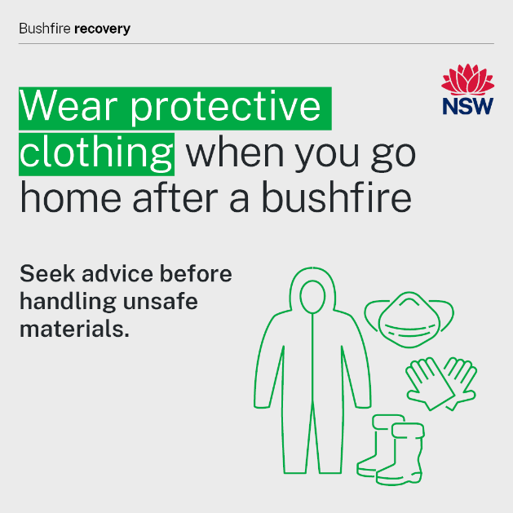 | It is important to wear protective clothing if you are returning home after a bushfire.  What to wear:  - protective clothing including sturdy footwear and heavy-duty work gloves  - disposable coveralls (with long sleeves and trousers)  - P2/N95 face masks.  You can buy these you’re your local hardware or workplace supply stores.  When it’s time to leave the property:  - pack all protective clothing items into a garbage bag  - wash your hands after removing your protective clothing  - clean your shoes before wearing them again.​​  For more information on returning home safely:  https://www.health.nsw.gov.au/environment/bushfire/Pages/bushfire-recovery.aspx
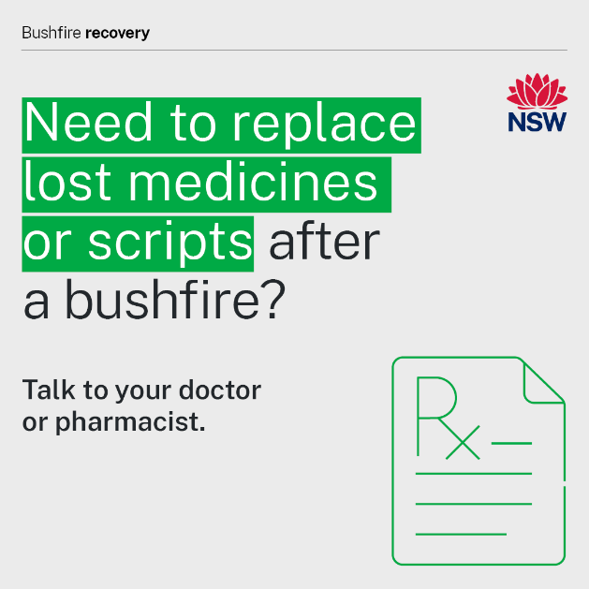 | If you had to leave home without your prescriptions or medications, or they are lost, contact your doctor.​  Your doctor can send your prescription to a pharmacist near you.  During and after a bushfire a local pharmacy can provide you with an emergency supply of some medicines without a prescription if you cannot contact your doctor.  Follow the advice of local emergency services about how to safely access health services during a bushfire.  For more information: https://www.health.nsw.gov.au/environment/bushfire/Pages/bushfire-medications.aspx
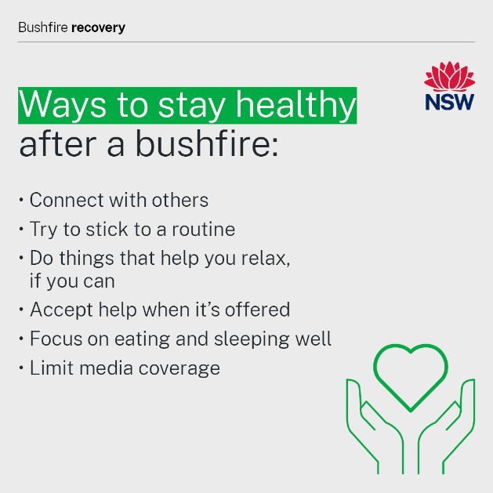 | It is completely normal to experience a range of emotions if you are directly or indirectly affected by bushfires.  These emotions may happen immediately, but sometimes much later, and may affect sleep, mood, anxiety and daily routines.  There are small things you can do to cope:  - Connect with others – spend time with friends and family and talk to them about you’re feeling.  - Try to stick to a routine and give your day structure by planning meals and going to bed at the same time every day.  - Do things that help you relax, like reading or listening to music, if you can.  - Accept help when it is offered – there’s no shame in needing and accepting help and support.  - Focus on eating and sleeping well and move your body if you can.  - Limit media coverage by taking breaks and sticking to one trusted source of information.  If you or someone you know needs to talk to someone, call:  - Lifeline on 13 11 14  - Beyond Blue on 1300 22 46 36  - Kids Helpline on 1800 551 800  - 13 YARN, run by Aboriginal people, on 13 92 76.  - Transcultural Mental Health Line on 1800 648 911.  If you or someone you know is in immediate danger, please call 000 or go to your nearest hospital emergency department.  For specialist mental health services call the NSW Mental Health Line on 1800 011 511.  For more information on managing your mental health: https://www.health.nsw.gov.au/mentalhealth/resources/Pages/bushfire-mental-health-support.aspx
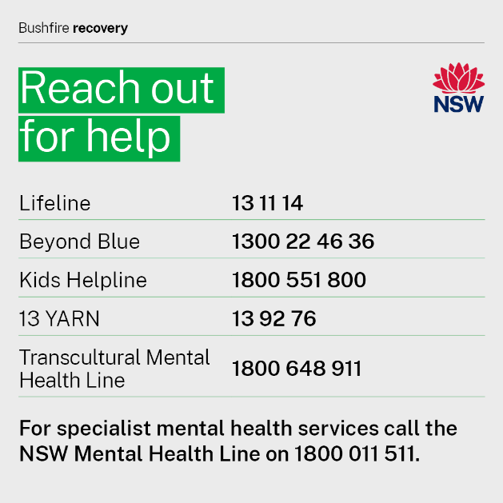 | It is completely normal to experience a range of emotions if you are affected by bushfires.  Take care of yourself and your mental health and seek support if you or the people around you need it.  A range of mental health services and professional help is available and only a phone call away.  If you or someone you know needs to talk to someone, call:  - Lifeline on 13 11 14  - Beyond Blue on 1300 22 46 36  - Kids Helpline on 1800 551 800  - 13 YARN, run by Aboriginal people, on 13 92 76.  - Transcultural Mental Health Line on 1800 648 911.  If you or someone you know is in immediate danger, please call 000 or go to your nearest hospital emergency department.  For specialist mental health services call the NSW Mental Health Line on 1800 011 511.  For more information on managing your mental health: https://www.health.nsw.gov.au/mentalhealth/resources/Pages/bushfire-mental-health-support.aspx

NSW Health
NSW Ministry of Health  1 Reserve Road  St Leonards NSW 2065 | Office hours:  Monday to Friday  9.00am — 5.00pm  W: www.health.nsw.gov.au

