NSW Health | Bushfire preparedness social copy
 | November 2023
v1 | www.health.nsw.gov.au

Social
Tile example (please use png file provided in channel) | Social copy
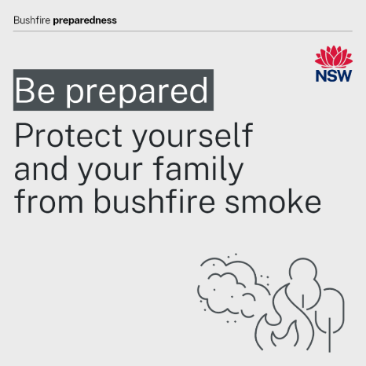 | Bushfire smoke contains fine particles that can affect your health.  Plan ahead and know what to do if the air quality is impacted by bushfire smoke in your area.  Things you can do to prepare:  - Know if you are at higher risk of illness from bushfire smoke.  - Talk to your doctor about how to protect yourself from bushfire smoke.  - Check your prescriptions and health action plans are up to date e.g. Asthma Action Plan, if you have one.  - Consider keeping a supply of P2/N95 face masks at home and to learn how to fit these well. If you have a heart or lung conditions to talk to your doctor before using a mask.  Find out if you may be more at risk from bushfire smoke and what to do: https://www.health.nsw.gov.au/bushfires  To check the air quality in your area and to see recommended health advice: https://www.airquality.nsw.gov.au/
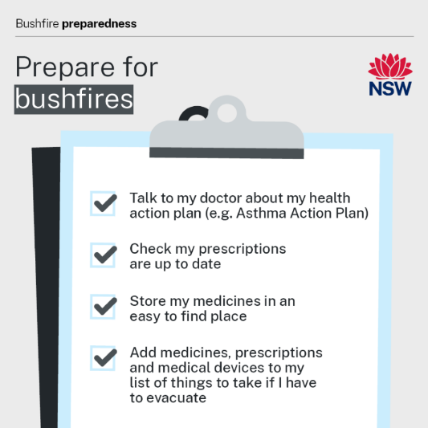 | Your health is important during a bushfire.  As part of your bushfire survival planning:  - Check your prescriptions are up to date  - Talk to your doctor about your health action plan if you have one (e.g. Asthma Action Plan)  - Keep your medicines and any paper prescriptions with your important items so they are quick and easy to find if you need to evacuate  - Ask your pharmacist about storing refrigerated medicines in an emergency. Have ice packs or ice bricks on hand if you need to leave your home because of a bushfire  - If you use a medical device that is easy to transport, such as a hearing aid or walking aid, plan to take it with you if you need to evacuate.  Learn more about protecting yourself and your loved ones: https://www.health.nsw.gov.au/bushfires
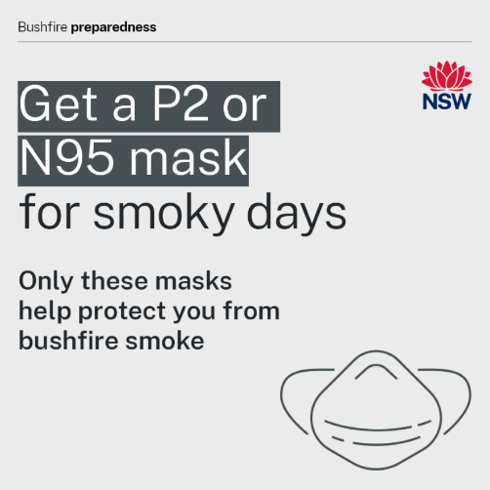 | Bushfire smoke contains fine particles that can affect your health.  Disposable P2/N95 face masks can filter out these particles from the air when worn correctly.  If you cannot avoid the smoke, consider keeping a supply of masks at home or in your bag this bushfire season.  Check with your doctor before using a P2/N95 face mask if you have a heart or lung condition.  P2/N95 face masks are not designed for children and therefore not recommended.  Surgical and cloth masks will not protect you from smoke.  Learn more about protecting yourself and your loved ones from bushfire smoke:  https://www.health.nsw.gov.au/bushfires
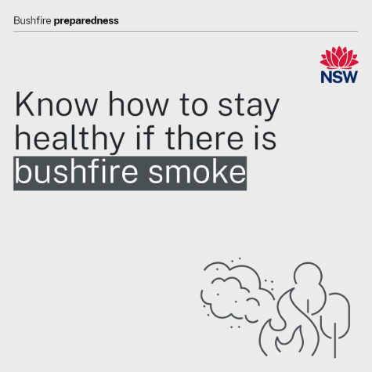 | Bushfire smoke can irritate your eyes, nose, throat and lungs. It can also make some people’s existing health conditions worse.  Things you can do to prepare:  - Talk to your doctor about how bushfire smoke might affect your health.  - Check your prescriptions and health action plans are up to date, e.g. Asthma Action Plan, if you have one  - Consider keeping a supply of P2/N95 face masks at home and to learn how to fit these well. If you have a heart or lung conditions to talk to your doctor before using a mask.  Find out if you may be more at risk from bushfire smoke and what to do: https://www.health.nsw.gov.au/bushfires  To check the air quality in your area and to see recommended health advice: https://www.airquality.nsw.gov.au/
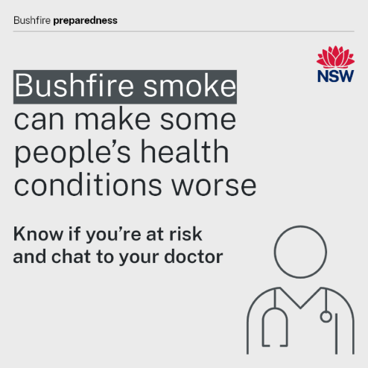 | Bushfire smoke can make some people’s existing health conditions worse.  You may be more sensitive to the health effects of bushfire smoke if you:  - have a pre-existing heart or lung condition like asthma, emphysema and angina  - are pregnant  - are aged over 65  - are an infant or a young child  - have diabetes.  Chat to your doctor now about how bushfire smoke might impact your health.  Find more resources to help you plan for managing your health when it is smoky: https://www.health.nsw.gov.au/environment/bushfire/Pages/know-high-risk.aspx
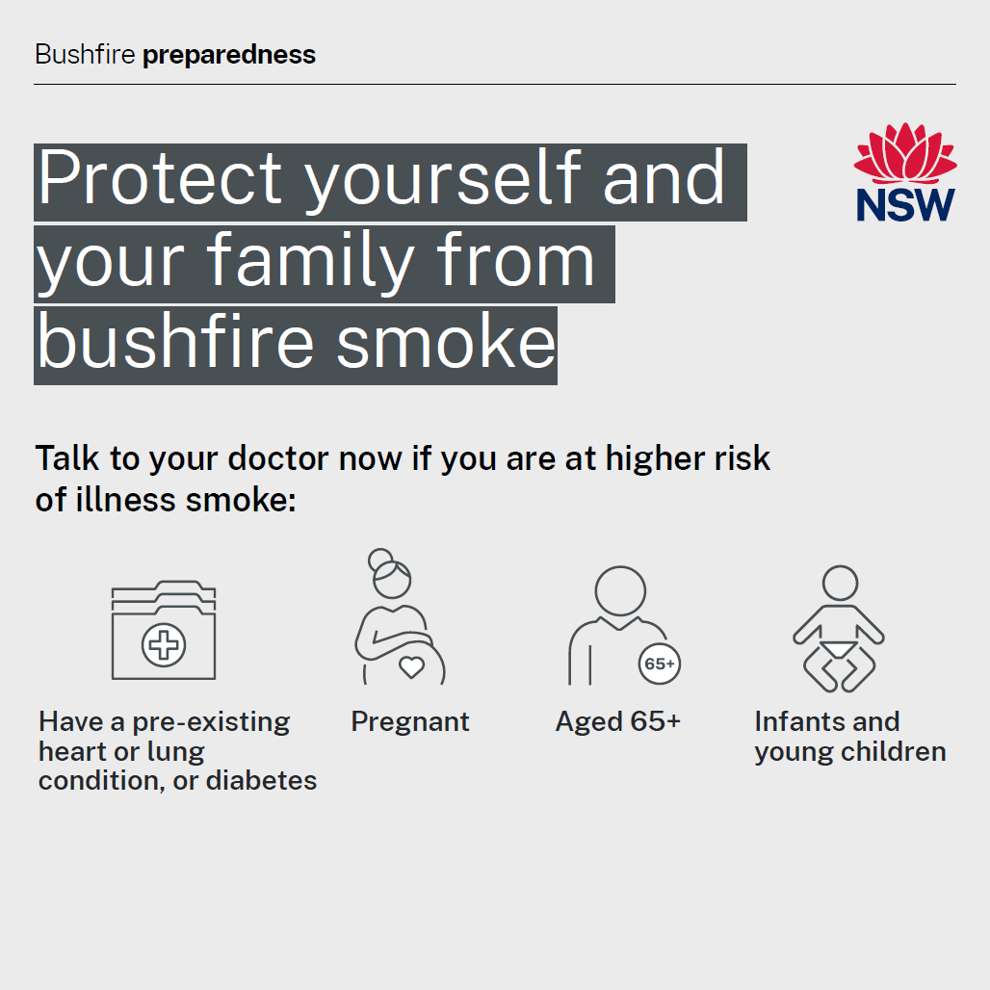 | Some people are more sensitive to the health effects of bushfire smoke.  You might be more sensitive to smoke if you:  - have a pre-existing heart or lung condition like asthma, emphysema and angina  - are pregnant  - are aged over 65  - are an infant or a young child  - have diabetes.  Talk to your doctor about what you need to do if there is bushfire smoke about.  Check your health action plan and any prescriptions you have for your health conditions are up to date.  Store your medicine in an easy spot for you to get quickly if you need it.  Know if you are at higher risk from bushfire smoke: https://www.health.nsw.gov.au/environment/bushfire/Pages/know-high-risk.aspx  Find more information on preparing for bushfire season: https://www.health.nsw.gov.au/environment/bushfire/Pages/prepare-for-bushfire.aspx

NSW Health
NSW Ministry of Health  1 Reserve Road  St Leonards NSW 2065 | Office hours:  Monday to Friday  9.00am — 5.00pm  W: www.health.nsw.gov.au

